**Day1**

installing: Cmd is npx create-react-app my-app, sometimes we will get errors.

1) npm folder will not create in app roaming folder need to create

2) set-executionpolicy remotesigned (if we get some other error)

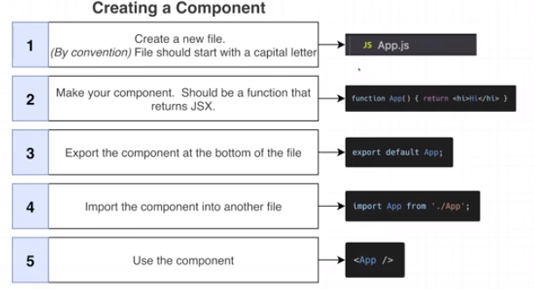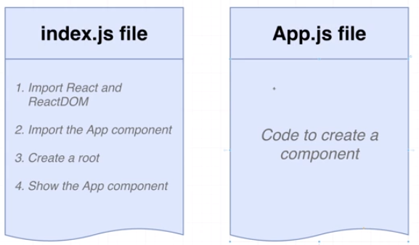

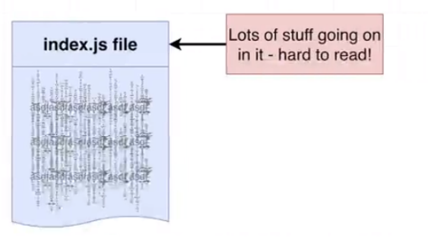

<https://www.udemy.com/course/react-redux/>

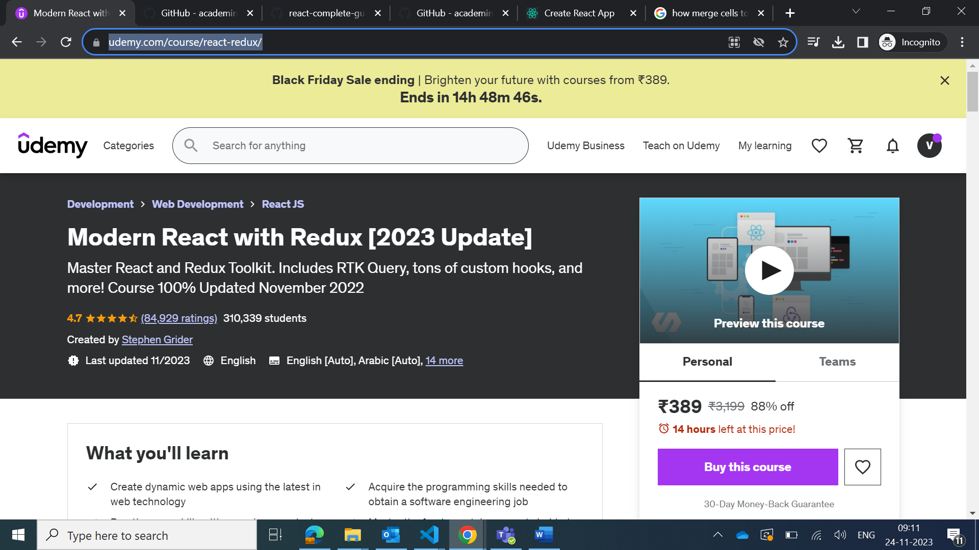

Code day 1

//1) import the React and ReactDOM libraries

//2) Get the reference to the div with ID root

//3) Tell React to take control of that element

//4) Create the component

//5) Show the component on the screen

//React: Library that defines what a component is and how muliple components work together

//ReactDOM: Library that knows how to get a component to show up in the browser

import React from 'react';

import ReactDOM from 'react-dom/client';

const el = document.getElementById('root');

const root = ReactDOM.createRoot(el);

function App(){

  // return <h1>hi there guys you there</h1>;  //jsx //html code

//javascript code

  let message = "today is react course";

  if(Math.random() > 0.5){

    message = "starting react code"

  }

  return <h1>{message}</h1>

  //curly braces means we are about to refernce a JS variable

  //we mostly use curly braces to show strings and numbers

  const something1 = "venkat is here"; //this will work

  const something2 = 10; //this will work

  const something3 = true;

  const something4 = false;

  const something5 = {};

  const something6 = [1, 2, 3];

  return <h1>{something4}</h1>

  //shorthand JS expressions

  const date = new Date();

  const time = date.toLocaleTimeString();

  return <h1>{time}</h1>

  return <h1>{new Date().toLocaleTimeString()}</h1>

}

root.render(<App />);